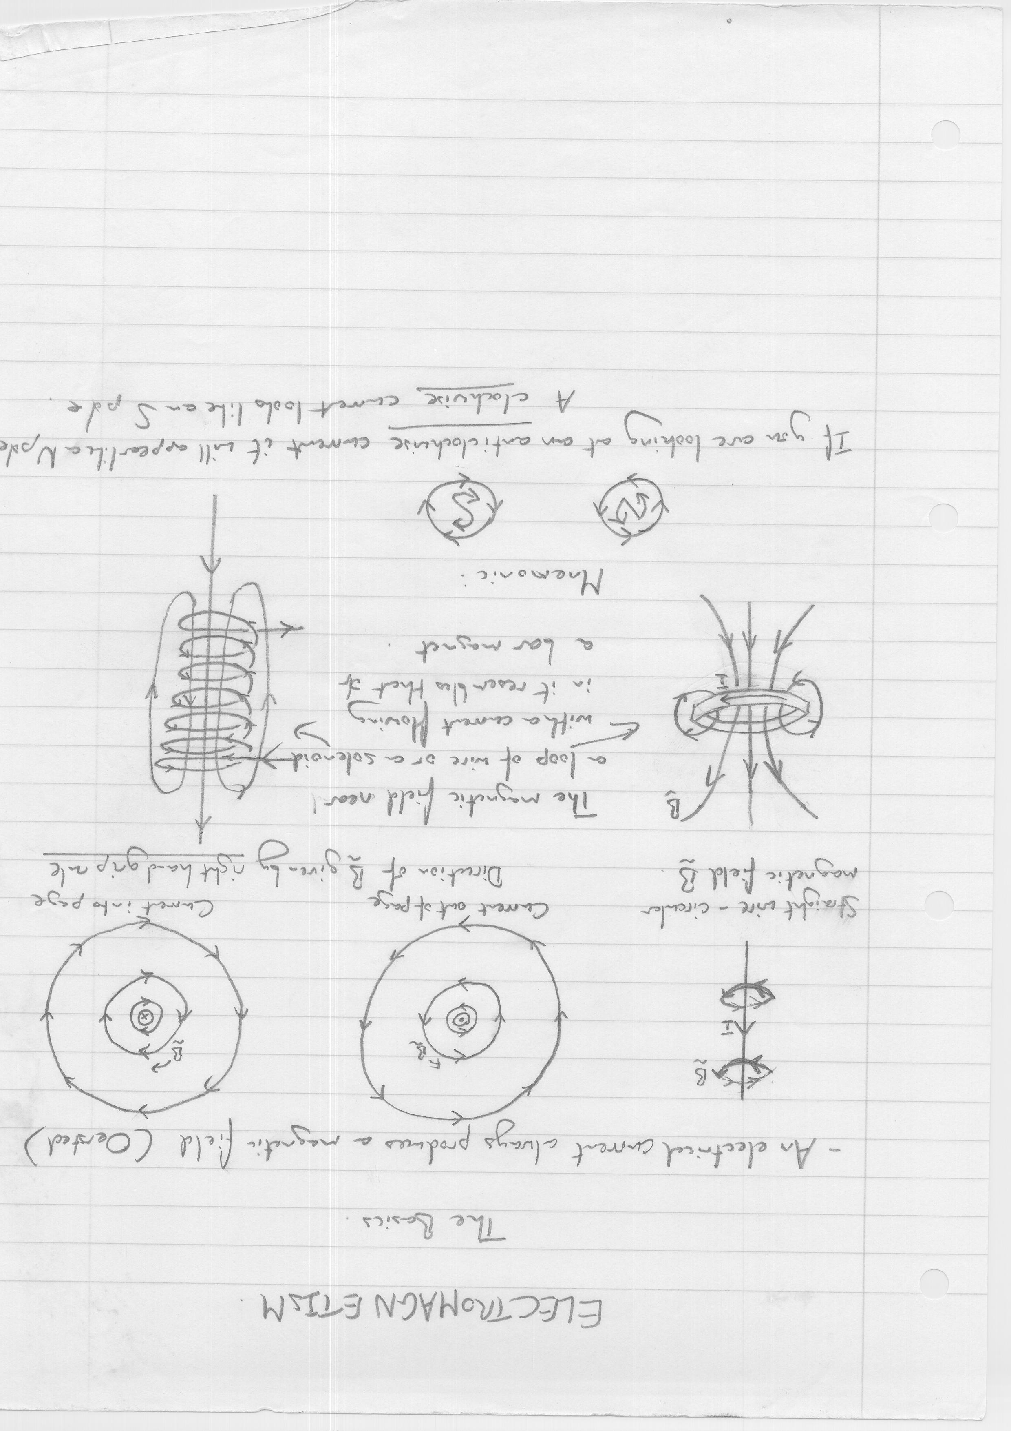
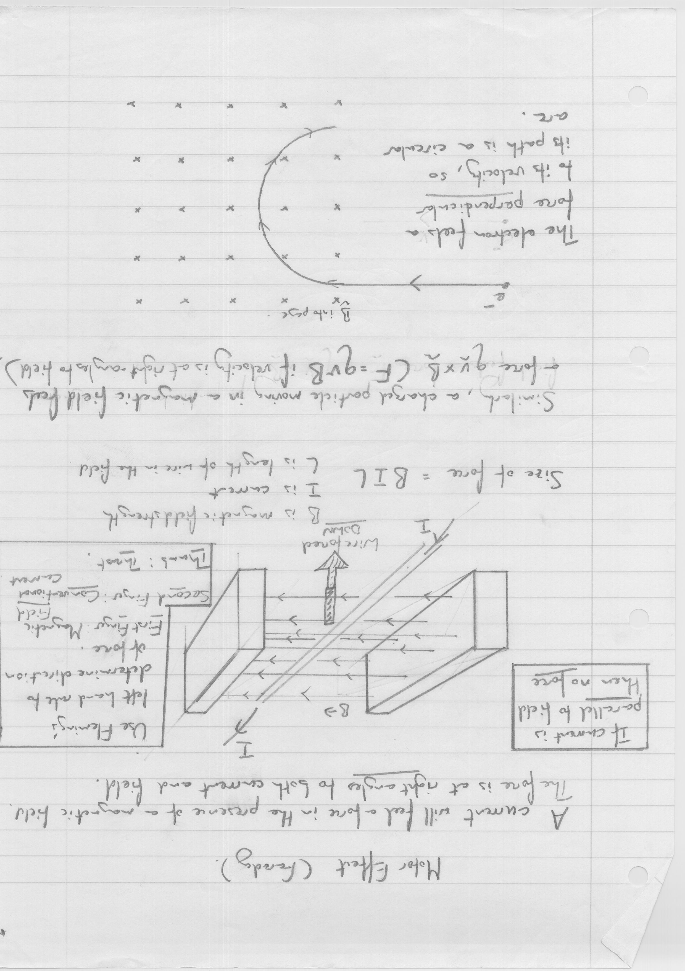
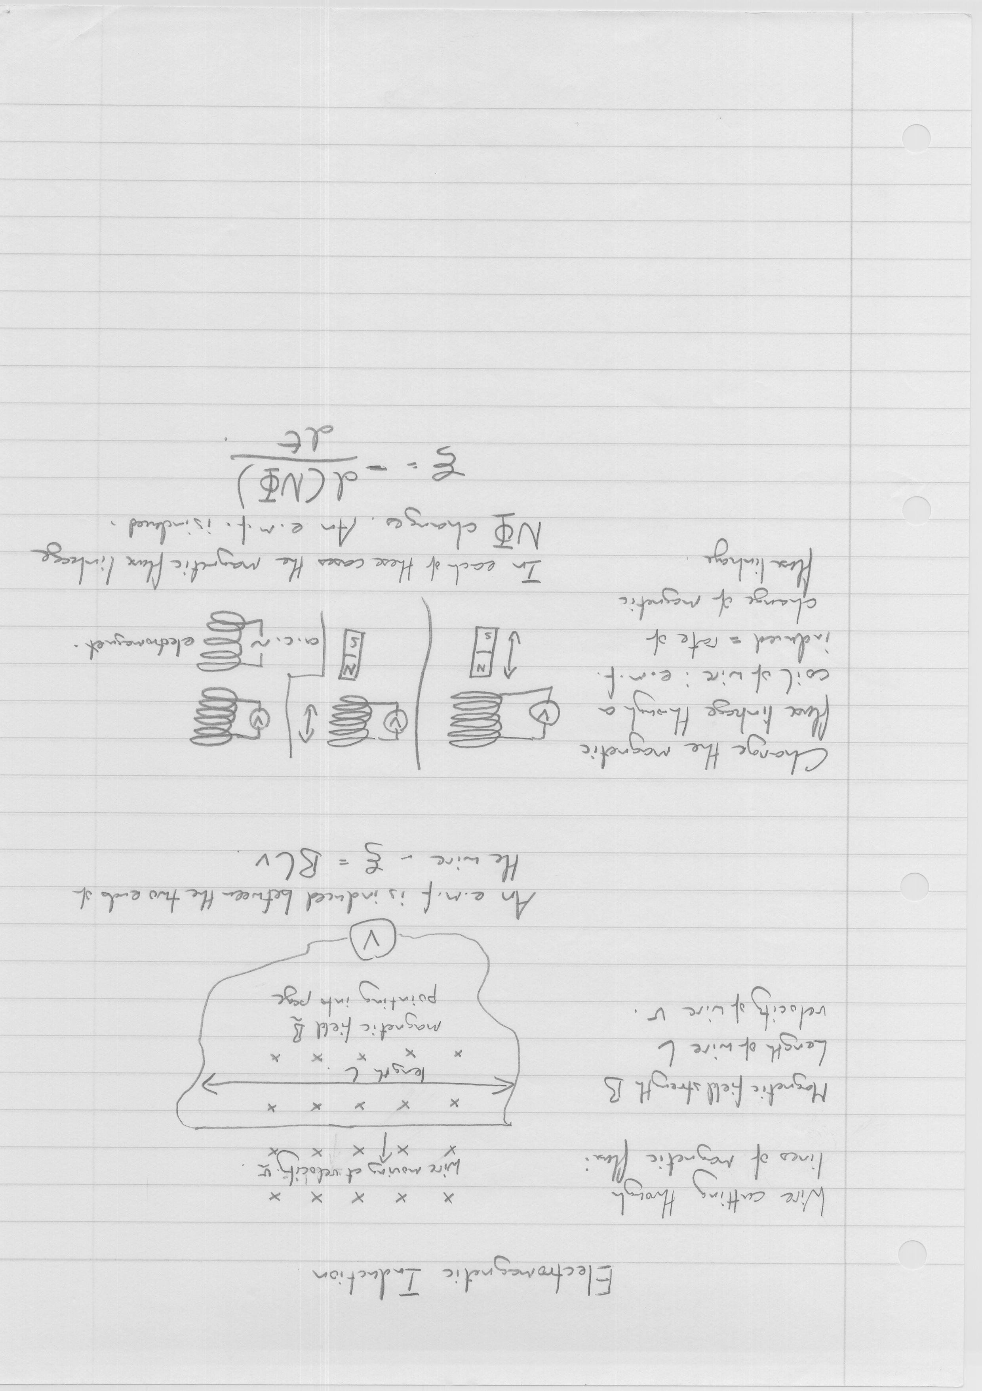
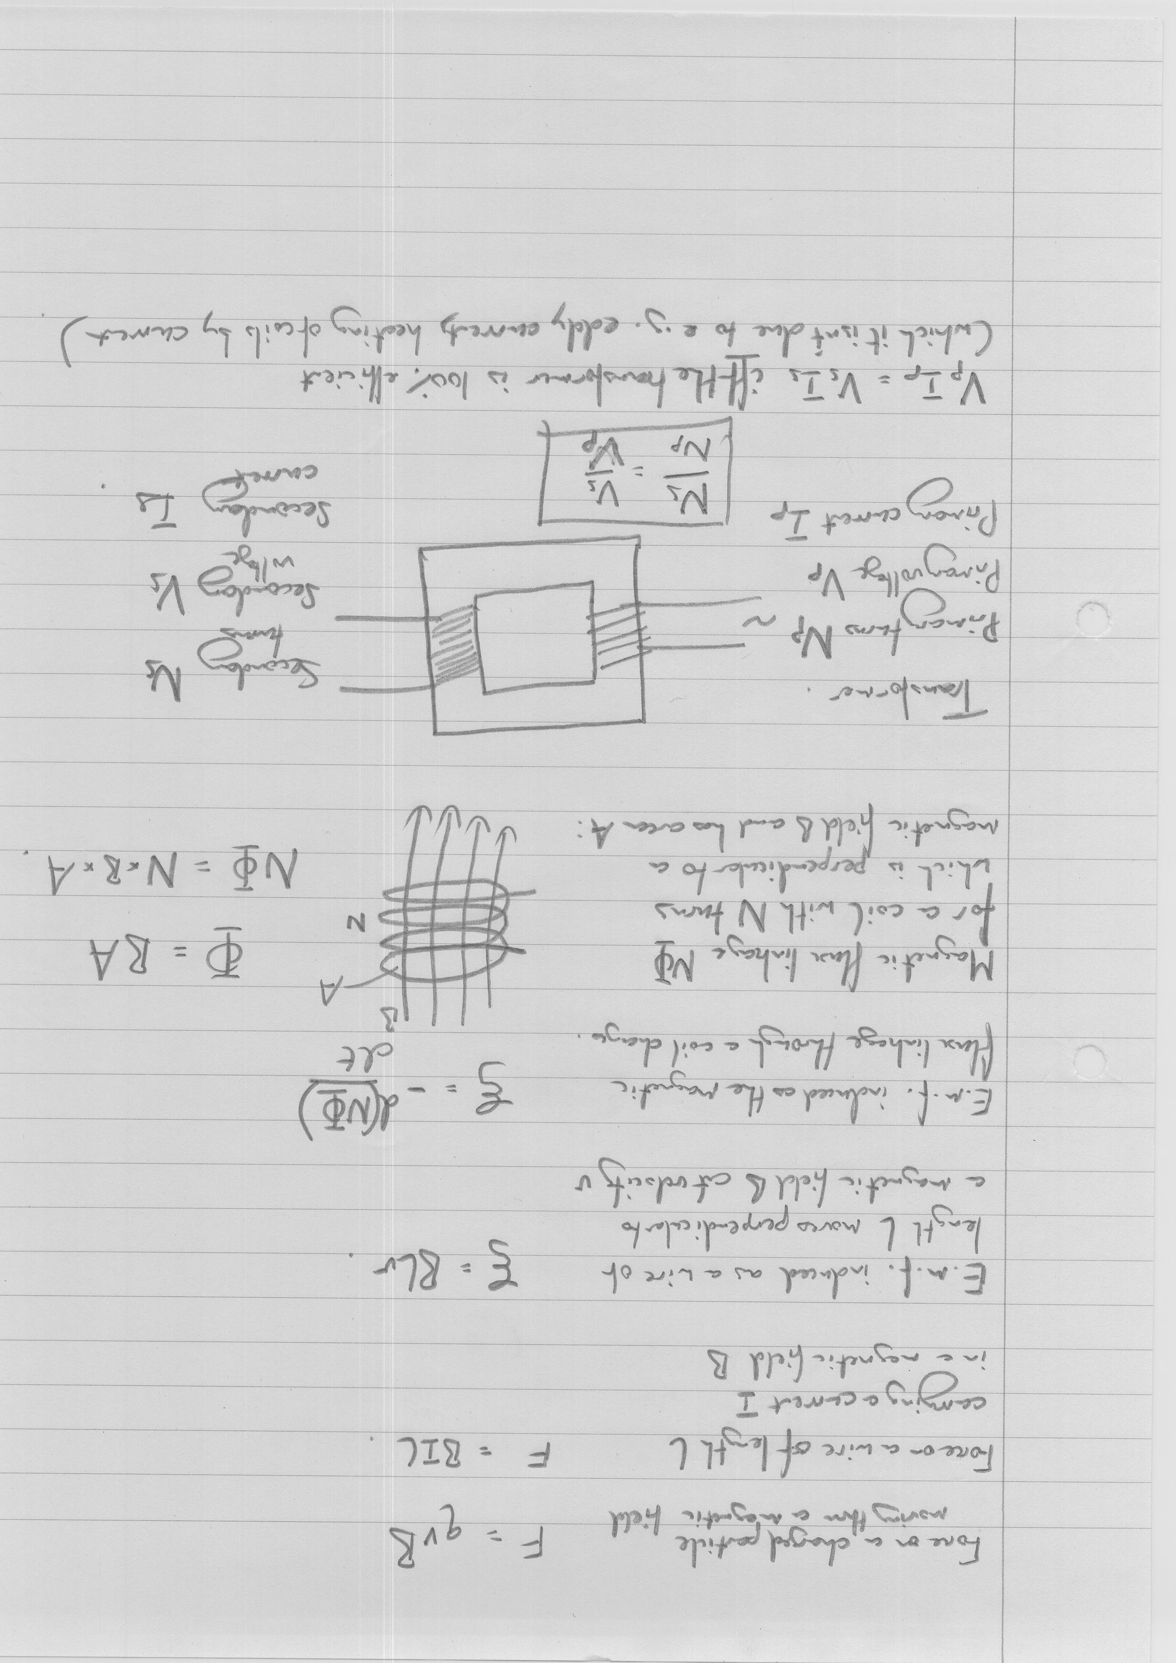
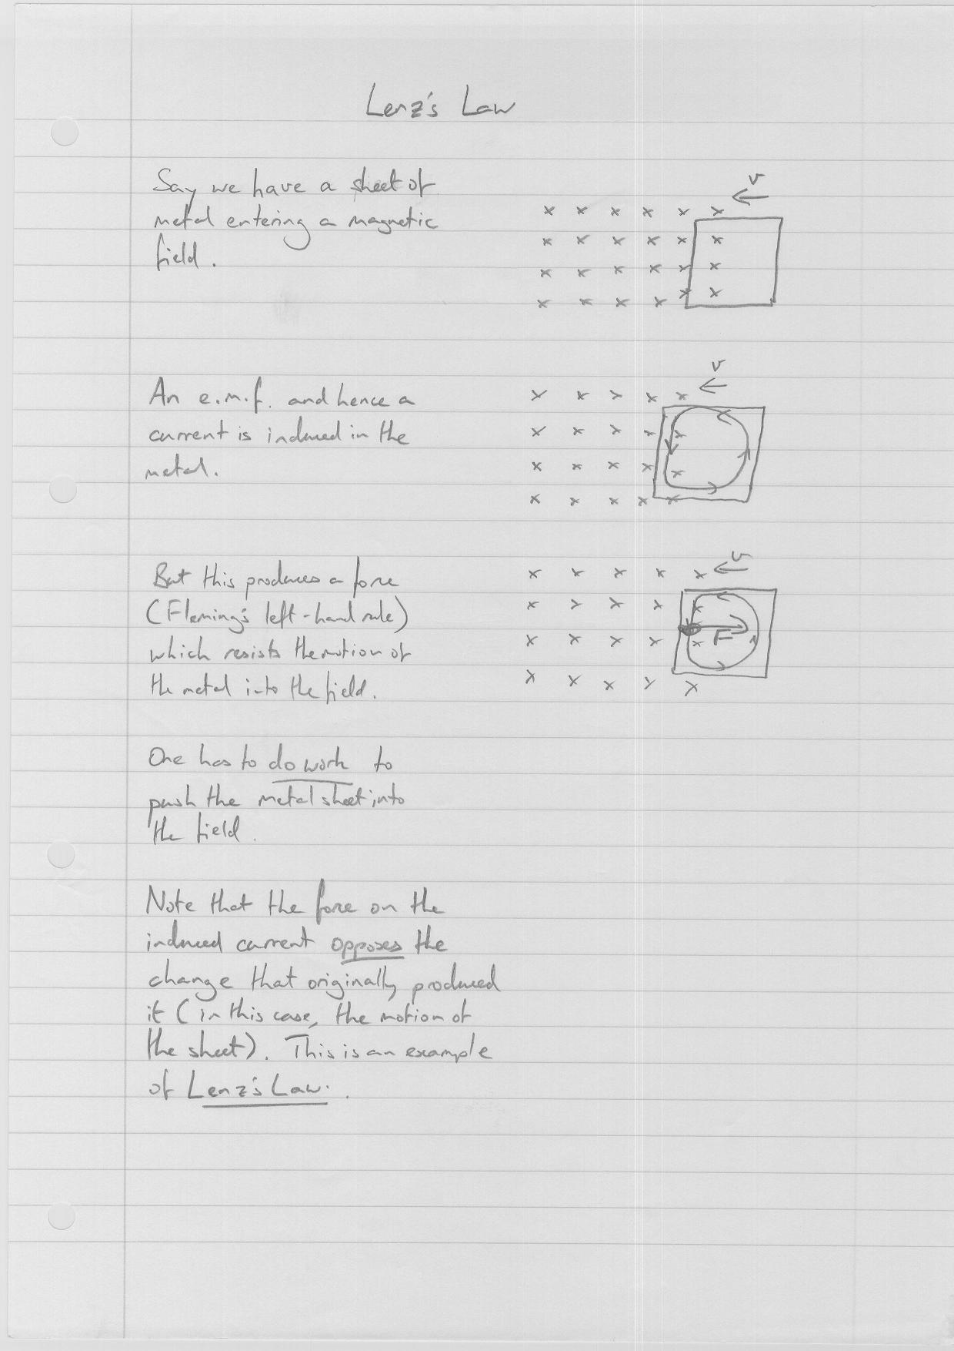
A charged particle moving at right angles to a magnetic field will experience a force qvB perpendicular to its motion. It will thus follow a circular path.

qvB = mv²/r => r = mv/Bq

Mass spectrometer: ionise an atom and accelerate it with a fixed potential difference V giving it energy qV. Kinetic energy ½ mv² = qV thus  so for a given q and B a larger m will give a larger radius of curvature. Thus only atoms with a particular mass will arrive at a particular detector.  (Image from http://en.labs.wikimedia.org/wiki/IB_Chemistry_Atomic_Theory) | 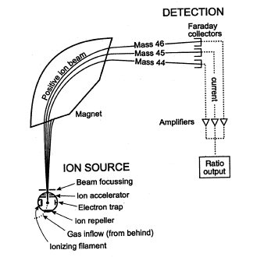

Hall probe: A thin strip of semiconductor with thickness d with a current flowing in it is held at right angles to a magnetic field B.
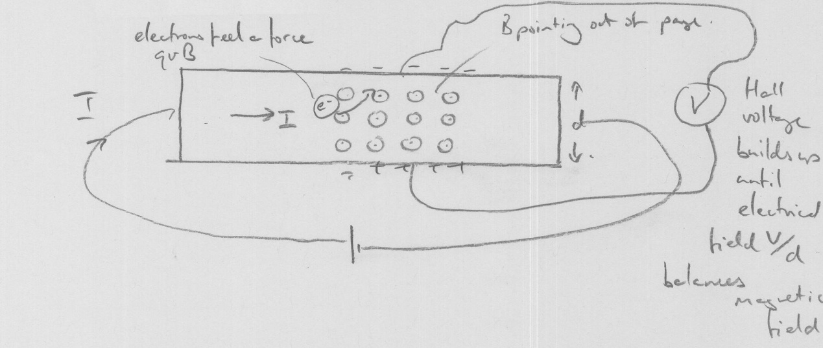
Force on the electrons qvB pushes them at right angles to the field. A potential difference V (Hall voltage) builds up between one side and the other until the electrical field V/d cancels out the effect of the magnetc field.

qV/d = qvB => V = Bvd

V is thus proportional to B – it can be measured, and so you can use the Hall probe to measure the magnetic field B.

