2016 VI Book 1 Physics Mock Examination: Markscheme

WEB/MJR Variant: Block C

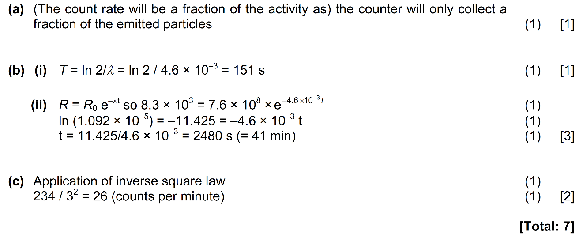
1.

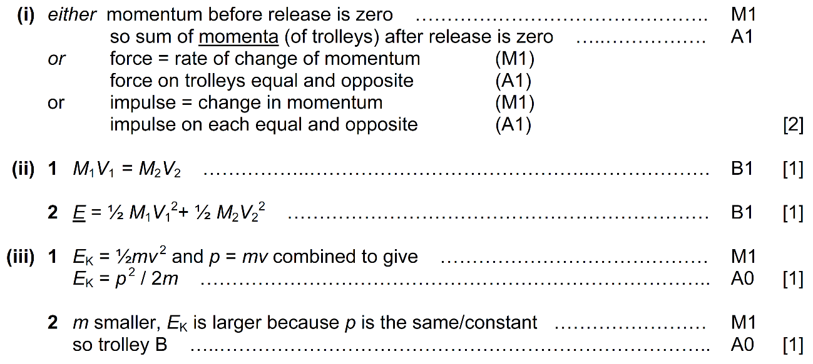
2.

[Total:6]

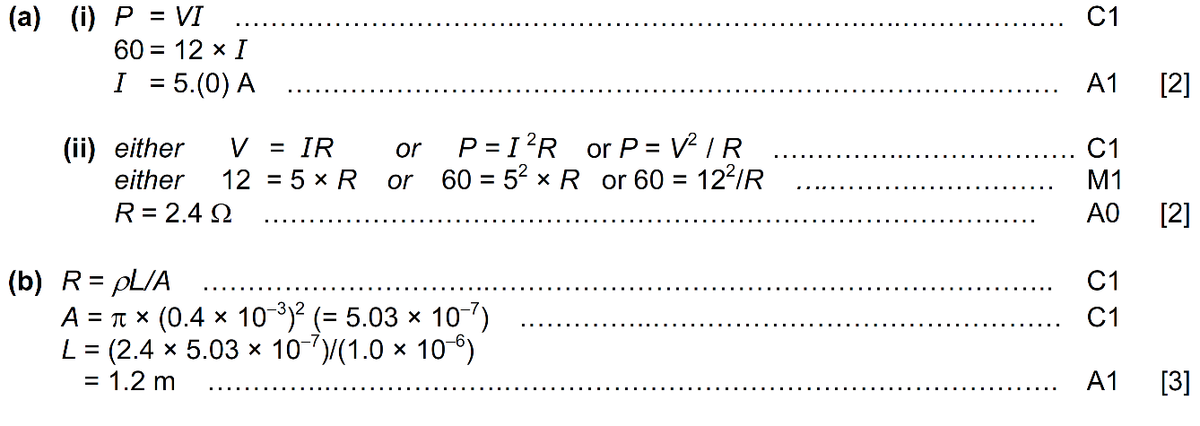
3.

[Total:7]

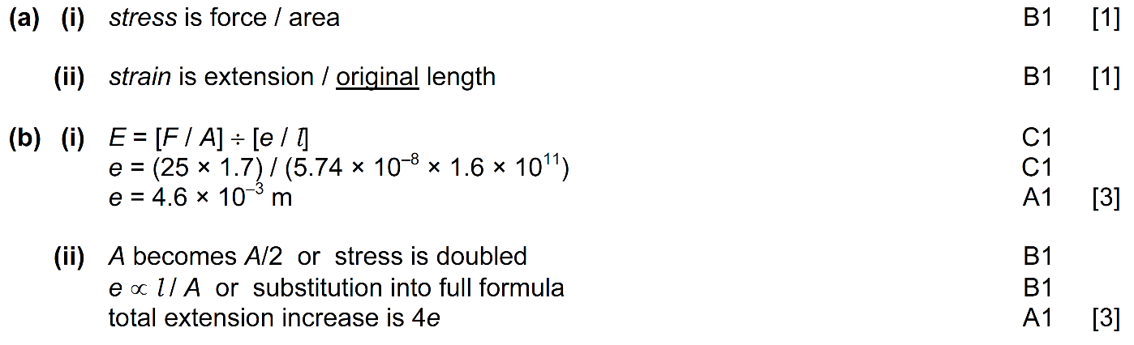
4.
[Total: 8]

5. (a)
(i) temperature is 42°C [1]
(ii) use of potential divider argument [1]
p.d. across thermistor = 5.9 V [1]

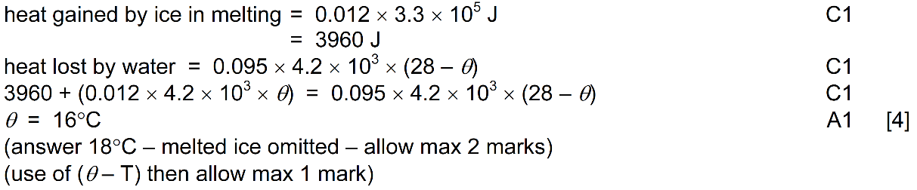
(b)

[Total: 7]

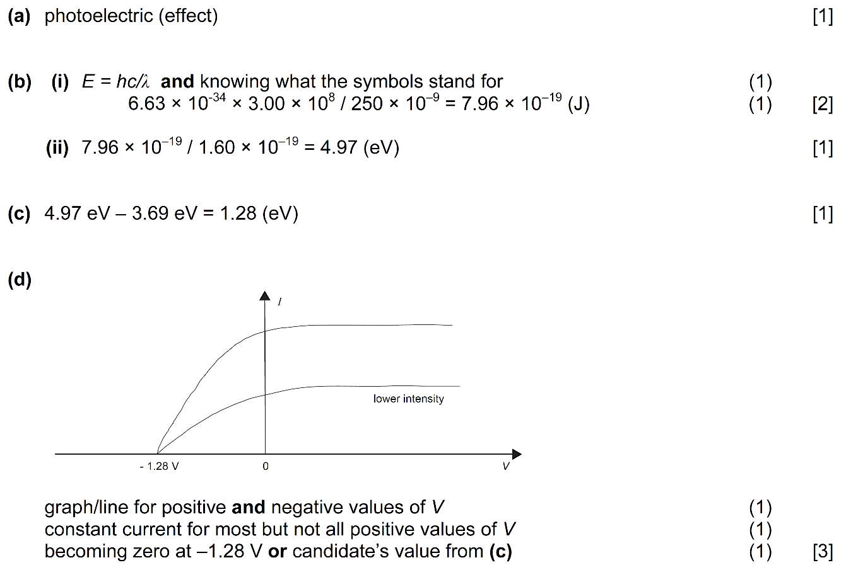
6.

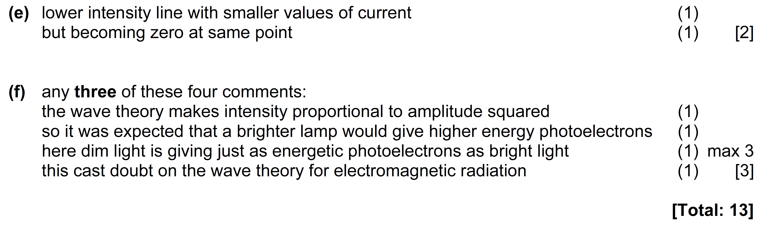

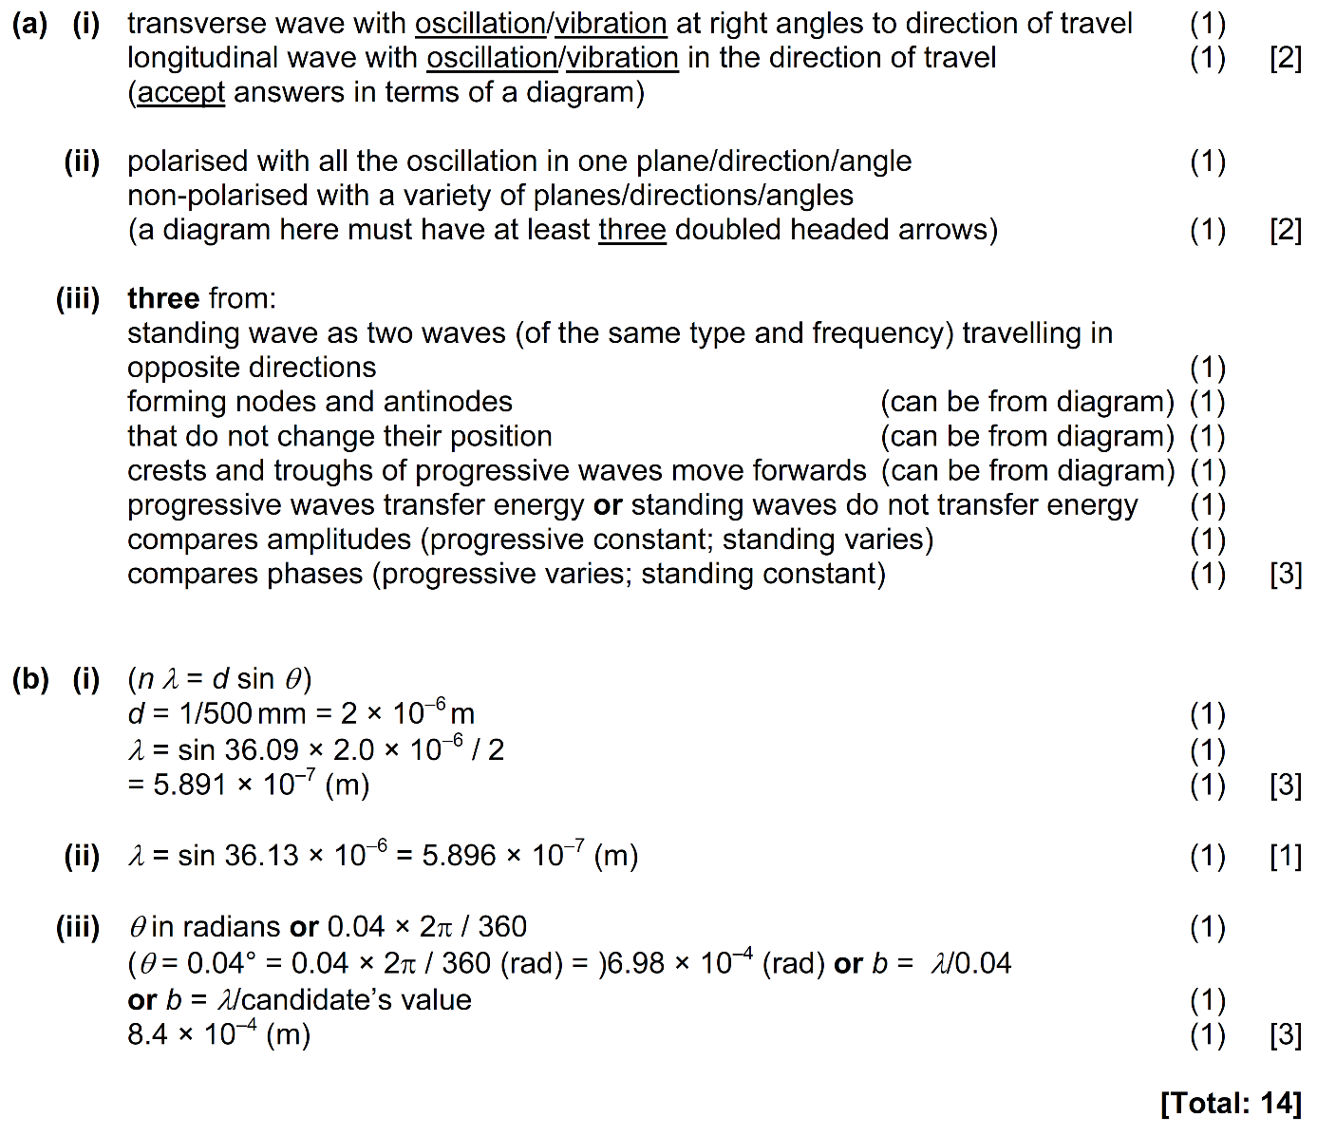
7.

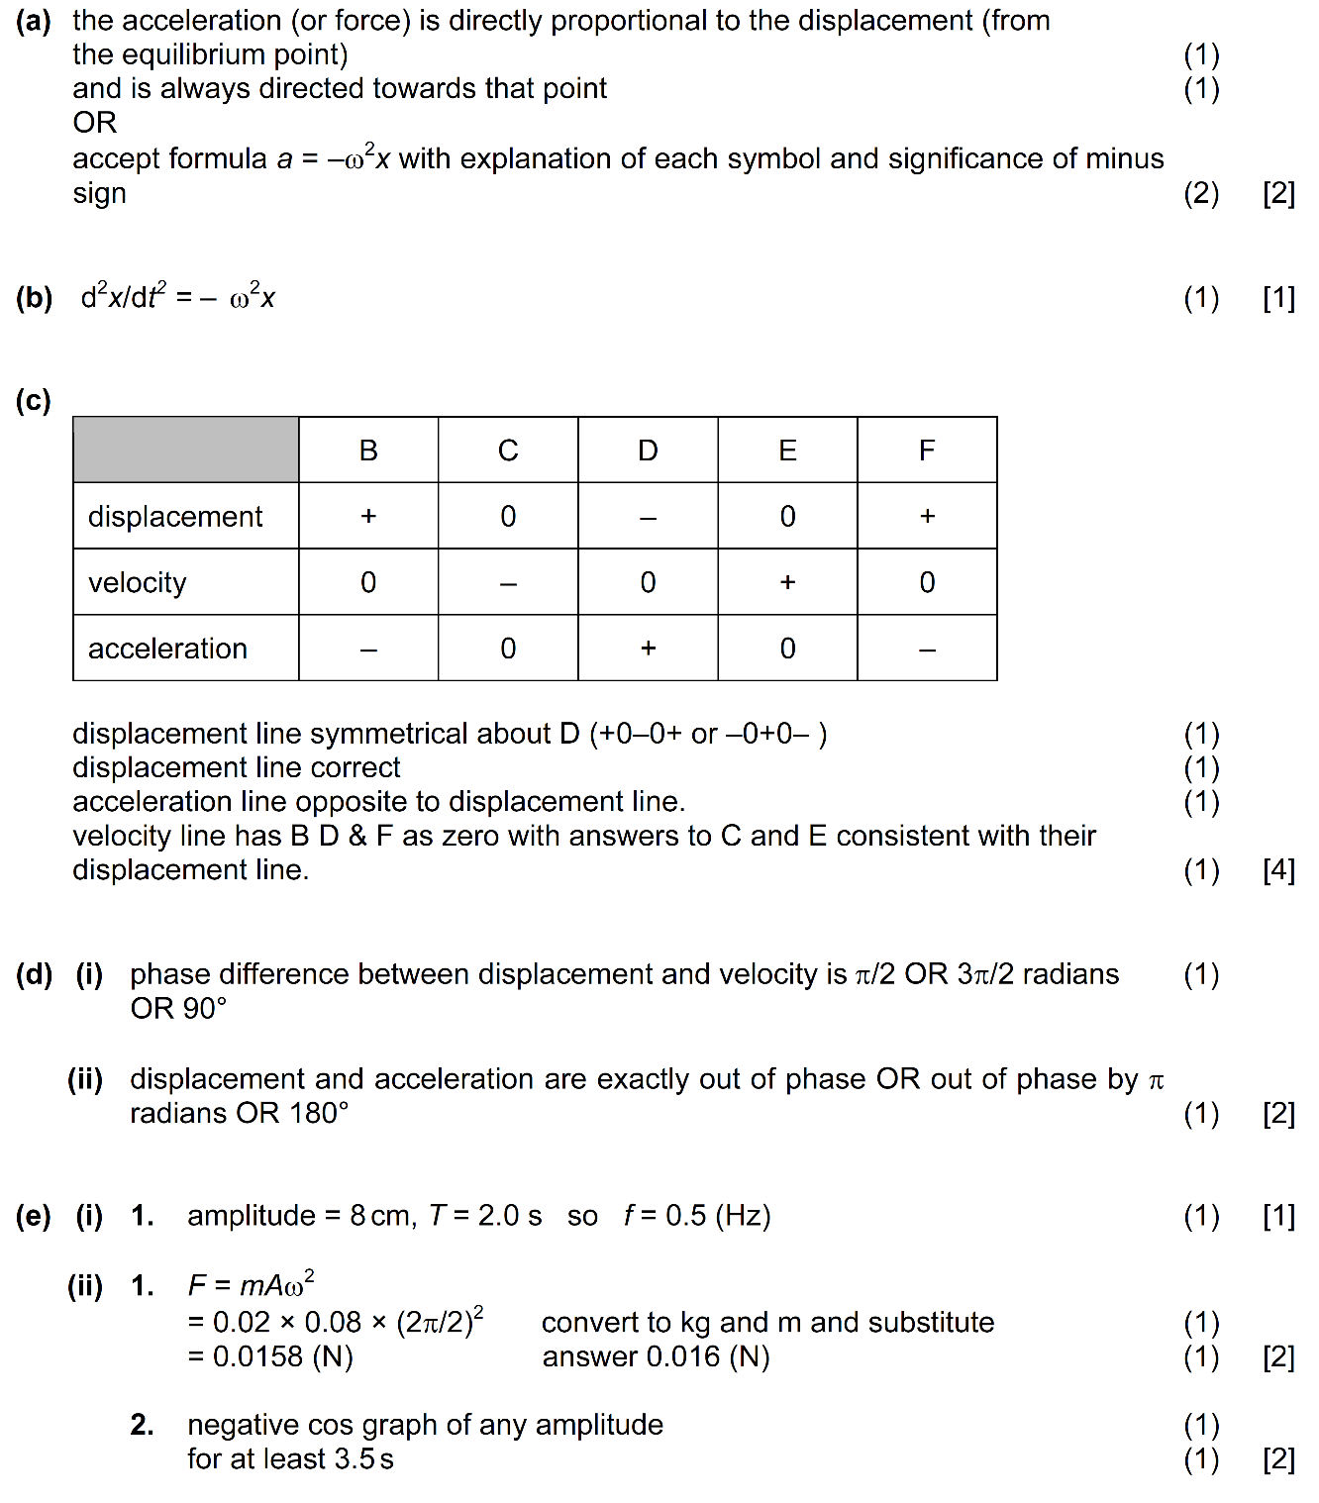
8. 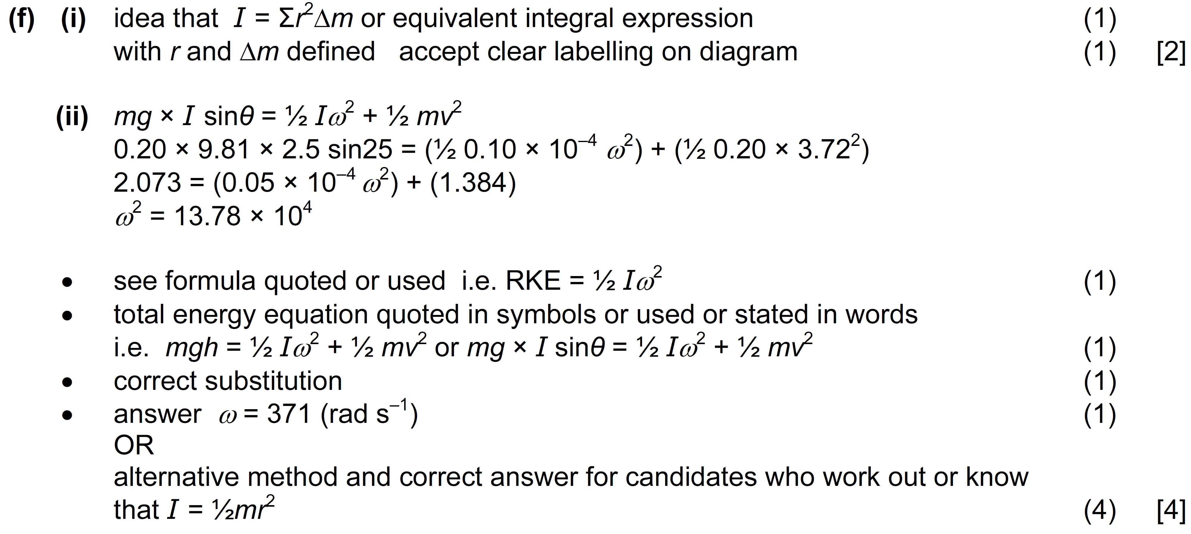
Part (d) deleted and all subsequent parts relettered
[Total: 18]
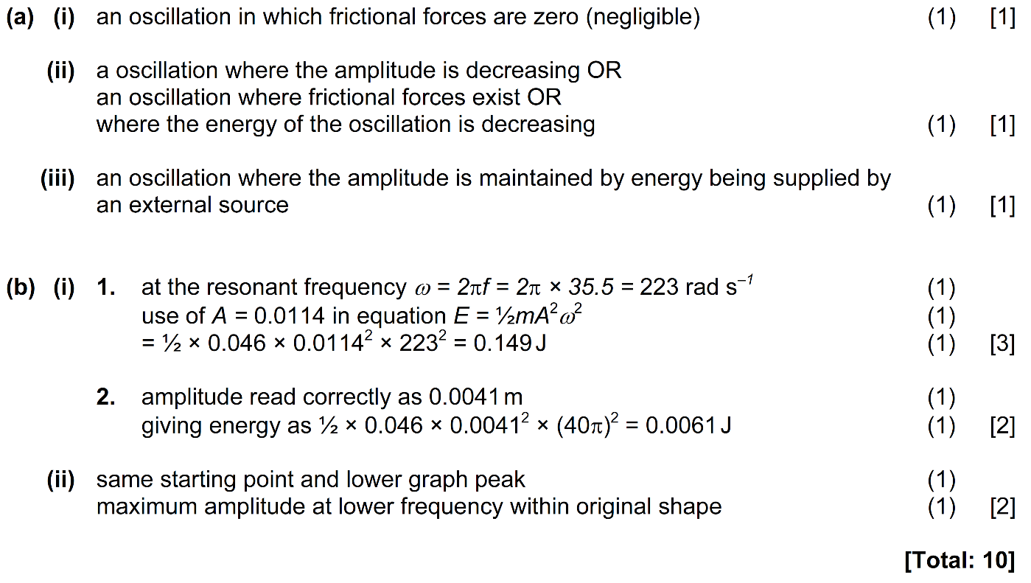
9.

[Paper Total: 90 marks]

